H.T No
Regulations:
A17

Sreenidhi Institute of Science and Technology
(An Autonomous Institution)
Code No: 6C731 Date: 10-Mar-2021(FN)

B.Tech IV-Year I- Semester External Examination, March/April - 2021 (Regular)
FPGA ARCHITECTURE AND APPLICATION (ECE)

Time: 3 Hours Max.Marks:75

Note: a) No additional answer sheets will be provided.
b) All sub-parts of a question must be answered at one place only, otherwise it will not be valued.
c) Missing data can be assumed suitably.

ANSWER ANY 5 OUT OF 8 QUESTIONS. EACH QUESTION CARRIES 15 MARKS.

Bloom's Cognitive Levels of Learning (BCLL)

Remember | L1 | Apply | L3 | Evaluate | L5
Understand | L2 | Analyze | L4 | Create | L6

 |  |  | BCLL | CO(s) | Marks
1. | a) | Calculate the f₁ and f₂ of logic circuit shown in below figure and identify the logic circuit is PLA or PAL?  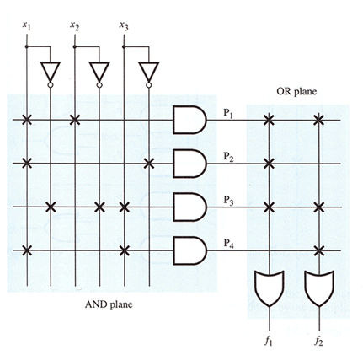 | L3 | CO1 | [8M]
 | b) | Explain the architecture of Altera Flex logic -10000 series CPLD. | L2 | CO1 | [7M]
2. | a) | Illustrate the CLB and programmable I/O blocks of FPGA. | L4 | CO2 | [8M]
 | b) | Write about logic cell, slice and CLB of Spartan 3 FPGA. | L1 | CO2 | [7M]
3. | a) | Design a gate level implementation of a 1-bit comparator. | L4 | CO3 | [8M]
 | b) | Show the Generation and download of the configuration file to an FPGA device. | L3 | CO3 | [7M]
4. | a) | Discuss about the parameter and constant of RTL code. | L2 | CO4 | [8M]
 | b) | Demonstrate a RTL code for 7 segment LED to display square pattern. | L1 | CO4 | [7M]
5. | a) | Write a RTL code for counter to count the heartbeat. | L1 | CO5 | [8M]
 | b) | Design a dual-edge detectors using Mealy machine-based design. | L4 | CO5 | [7M]
6. | a) | Explain about the method to incorporate memory modules. | L2 | CO6 | [8M]
 | b) | Develop a template for a Dual-port RAM with asynchronous read. | L4 | CO6 | [7M]
7. | a) | Show the architecture of Complex Programmable Logic Device. | L3 | CO1 | [5M]
 | b) | Identify the various versions of Xilinx FPGA. | L1 | CO2 | [5M]
 | c) | Write the test bench code for decoder circuit. |  | CO3 | [5M]
8. | a) | Explain about Incomplete branch and incomplete output assignment error in combinational circuit codes. | L2 | CO4 | [5M]
 | b) | Show the ASM chart of dual edge detector on Moore machine. | L3 | CO5 | [5M]
 | c) | Distinguish between Dual-port RAM with asynchronous read and single port RAM. | L2 | CO6 | [5M]

-- 00 -- 00 –

